**Honors Geom. Cevians – Review Name:**

1. State which congruence theorem you could use to prove ∆ABC∆AXY, or write NO if there is insufficient information for a proof.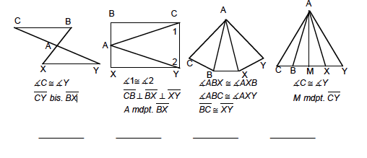

2. In the triangle at below which of these passes through point P?

(a) angle bisector from A

(b) median from B

(c) altitude from C 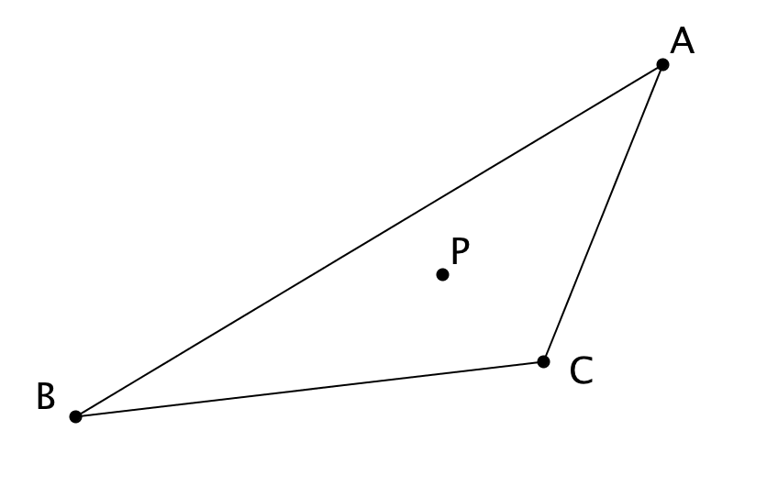3. In ∆PQR and 

a) List the three sides in order from smallest to largest

b) If PQ = 23 cm and PR = 19 cm, what is the range of possible values for QR? Write your answer as a compound inequality.

4. Construct the circle passing through the three points below using perpendicular bisectors.

P **.**

Q **.**

**.** R

5. The sides of a scalene triangle are all integers and the perimeter is 12 cm. a) What is the length of the longest side?

b) What is the size of the largest angle?

6. Construct the indicated point in each triangle below.

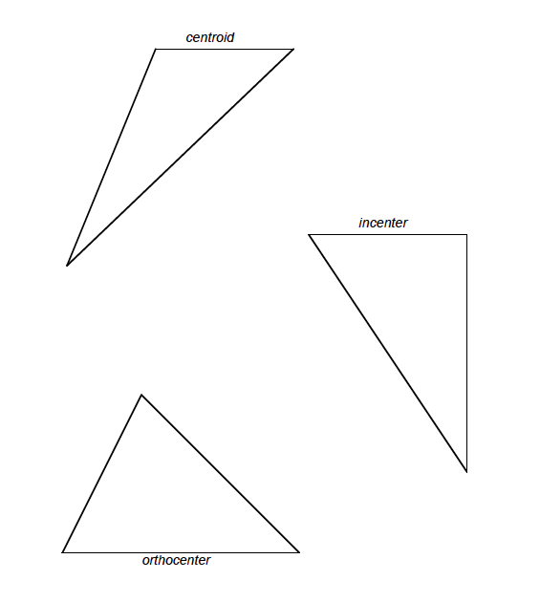

7. Construct the reflection of the object below over the line.

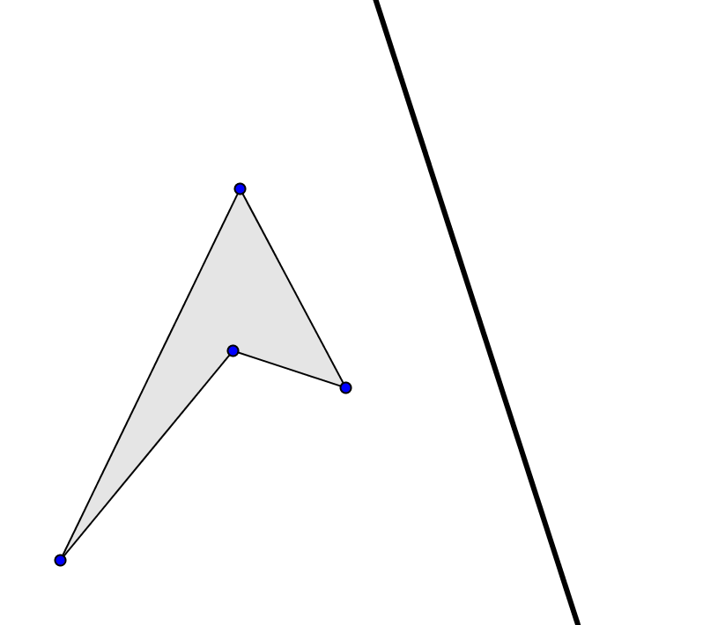

8. Write a **COMPLETE, CLEAR** proof.

Given: , 

Prove: 

9. Given the same diagram above and the information that , explain why . Don’t use congruent triangles, do use the concept of equidistance and perpendicular bisectors.