**H. Geom. Quads REVIEW Name_________________**

1. Identify each quadrilateral below
2. Diagonals congruent and two pairs of opposite congruent angles.
3. Diagonals perpendicular and has point symmetry.
4. Exactly one line of symmetry which also bisects angles.
5. Two pairs of opposite congruent sides.

2. Does SSSS work as a congruence theorem for quadrilaterals.

Make a drawing and *explain* your answer.

3. a. What is the greatest number of mutually congruent sides possible in a quadrilateral if it is *not* a rhombus? Make a sketch.

b. What is the greatest number of mutually congruent angles if *not* a rectangle? Make a sketch.

4. What quadrilateral is formed by joining the midpoints of a...

a) rectangle? b) square? c) kite?

5. A rhombus has a perimeter of 60 cm. Which of these could *not* be the length of one of its diagonals?

(a) 1 cm (b) 5 cm (c) 10 cm (d) 20 cm (e) all are possible

6. In the drawing of a trapezoid ABCD below, L, M, N and P are all midpoints (L and P are midpoints of AM and BN). LP = 51 and MN = 73. Find the length of .

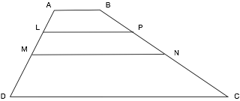

7. The lengths of the sides of quadrilateral PQRS are PQ = *x*2, QR = 20 - *x*,

RS = *x2* – 4 and PS = 1 – 4*x*. Find a value of *x* that will make PQRS a kite.

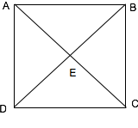8. *Given:* ,

, and



*Prove:*  ABCD is a rhombus

9. Two sides of quadrilateral ABCD are parallel and bisects. Identify and prove.