**PreCalc BC Trig. Review # 2 Name**

* means **NO CALCULATOR**

1. *Use a sketch to determine the value of 

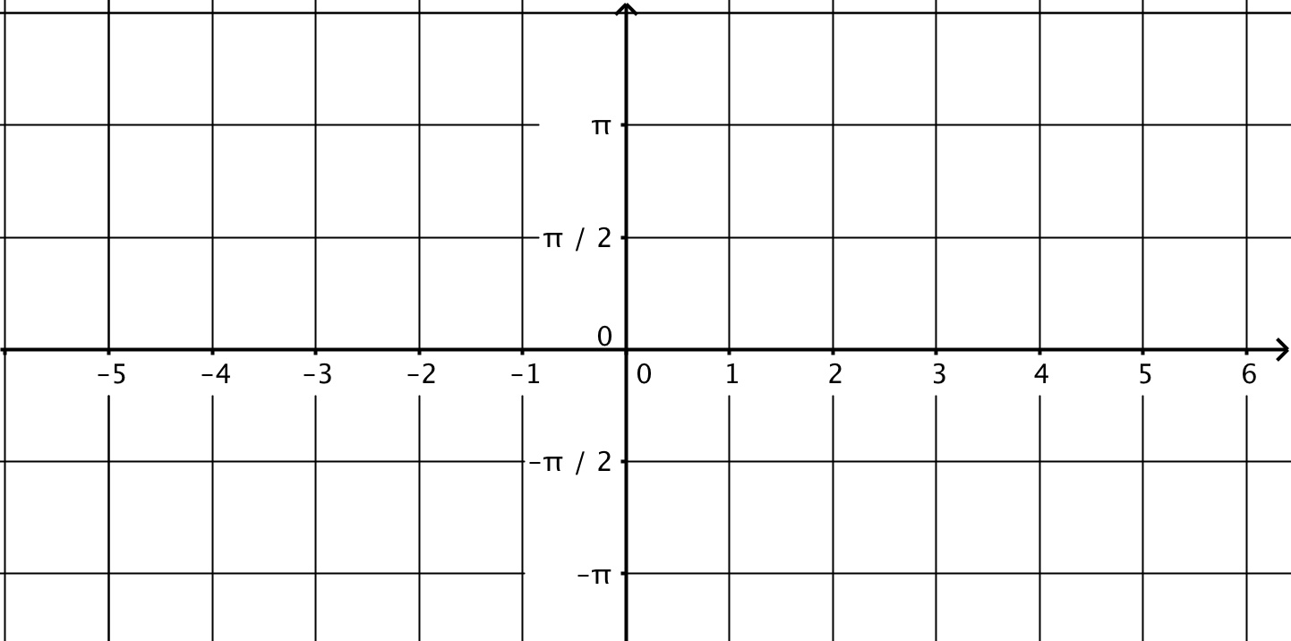

1. Determine which of the functions below can be expressed as a single sine function. If it is possible, do it!

a)  b)  c) 

1. *Find all solutions in the interval [0, 2π), **ALGEBRAICALLY** :

a)  b) 

1. Find the measure of the angle formed by terminal point (-9, -1) and the positive *x*-axis. Assume ().
2. *Investigate the following *graphically*. Make a good sketch and conjecture.

a) 

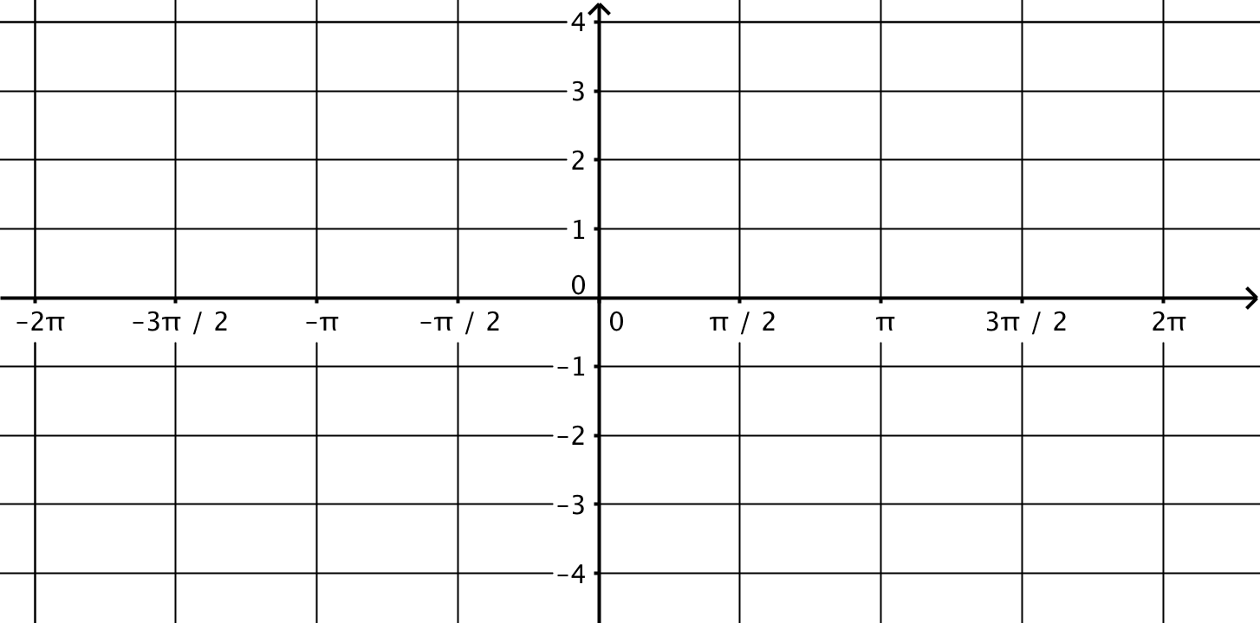

b) Solve the following *algebraically*:  for all values of *x* in the interval . Compare your answer to part *a*.

1. The center of a Ferris wheel is 45 feet high, and the radius of the wheel is 40 feet. It takes 96 seconds to complete a full revolution and the wheel turns counter-clockwise.

a) Write a sinusoid to model the height of a rider who starts at the 3:00 position.

b) Use you equation to determine when the rider is first at a height of 65 feet.

c) Determine the linear velocity of the rider.

d) How would your equation from part *a* change if the rider started at the 10:00 position?

1. *If , find each of the following

a)  b)  c)  d)

1. *Shown below is the graph of for the unit circle shown. Indicate how each of the following is conveyed in the graph. *(ie. Identify and label a length corresponding to each attribute directly on the graph – use a highlighter!)*

a) The diameter of the circle.

b) The circumference of the circle.

c) The arc length of 

d) The sin().

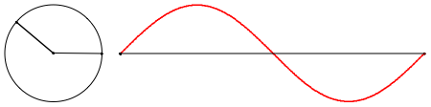

1. Write an equation for the function shown below. *(Verify by typing your equation into Geogebra or Desmos).*

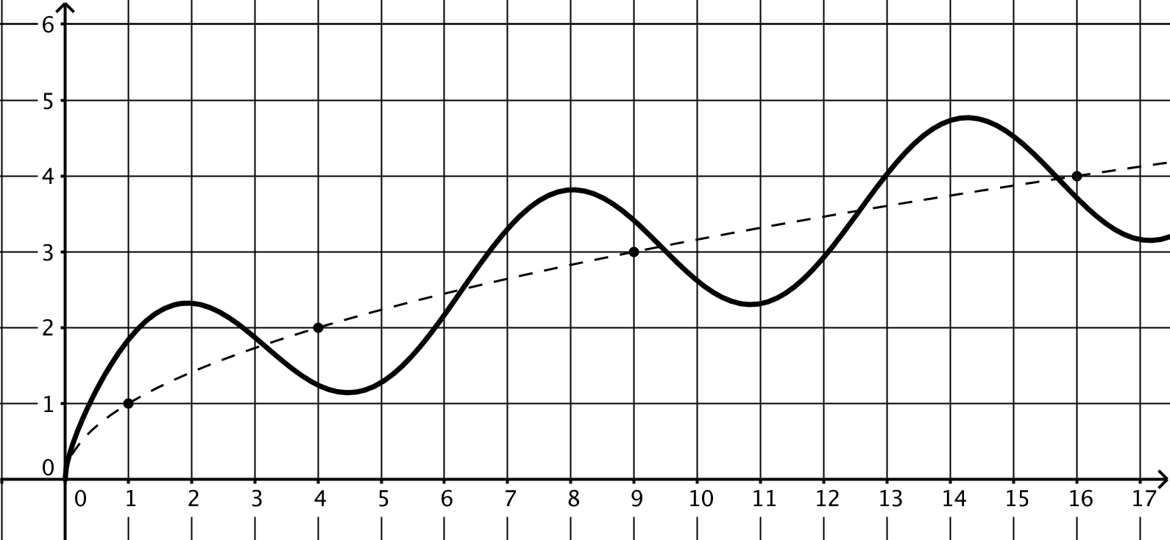

1. *Solve algebraically:  , 0 ≤ x < 2π

remnants

6. On a certain day in Capetown, South Africa, low tide occurs at 3:36 AM and the water at the end of a dock is 7.3 meters deep. High tide that day occurs at precisely 9:48 AM and the depth of the water at that time is 11.5 m.

Write an equation for the tide (*with t=0 at midnight)* and determine the depth of the water (*to the nearest cm*) at noon. SHOW YOUR WORK CLEARLY.

The distance in inches, *d*, of a swinging pendulum measured relative to a vertical wall is given by the equation  (*t is in seconds)*.

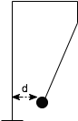

a) How far is the pendulum from the wall when *t* = 0?

b) How long is the period of a full swing?

c) After 10 full swings an observer notes that the pendulum is now 18” from the wall. Write a revised damped oscillation equation.

d) According to your equation how long will it take until the amplitude of the swings is less than 2 inches?

e) Where will the pendulum come to rest?