**Honors Geometry Cevians Name:**

1. On the triangle below construct and label...

a. the *altitude* from point A

b. the *angle bisector* from point B

c. the *median* from point C

d. the perpendicular bisector of .



2. a. Construct the line of symmetry of the two triangles below (hint: construct another segment first).

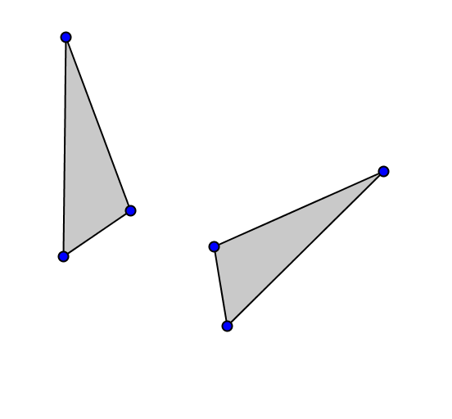

b. Construct the image of the triangle after a reflection over the line.

