Honors Geometry Hyperbolic - 1 Name:

**Answer the questions below as completely as possible. Use complete sentences and add sketches as needed. Work with a model before you try to answer the questions.**

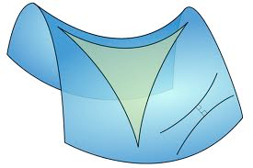1. Can a line on a hyperbolic surface intersect itself?

2. Can two different lines intersect more than once?

3. (Line Postulate) Do two points determine exactly one line?

4. (Parallel Postulate) Are there parallel lines (non-intersecting) on a hyperbolic surface? Given any line and a point not on the line, does there always exist exactly one parallel line through that point? Make a sketch!

5. To get a hyperbolic square on your graphing calculator graph the two functions:

 and  Use zoom-5 and make a sketch of what you see:

a) The *x*-axis and *y*-axis form the _________________________ of the square.

(*Starts with “D”!)*

b) What are the properties of the *diagonals* of a square? Are the same properties true in your hyper-square?

c) What are the properties of the *sides* of a square? Are the same properties true in your hyper-square? Are *adjacent*  sides parallel?

d) What are the properties of the *angles* of a square? Are the same properties true in your hyper-square? What are the angles?

e) What is the perimeter of your square?

f) What symmetry does your hyper-square have? How do these compare to the symmetries of a normal square?