PreCalc. BC Fundamental Theorem Name:

1. Use synthetic division to find the quotient:

a)  b) 

1. Use the remainder theorem to find the remainder of:

a)  b) 

1. According to the rational root theorem, which of the following could *not* be a rational root of ?

a) -1 b)  c)  d) -2 e) 3

1. Indicate whether the following statements are *true* or *false.* Assume all statements refer to polynomials with rational coefficients.
   1. *A polynomial of degree 5 must have 5 real roots.*
   2. *A polynomial of degree 5 must have 5 complex roots.*
   3. *If one root of a polynomial is* *, then*  *is also a root.*
   4. *The number 2 is a complex number.*
   5. *If r is a root of p(x), then (r, 0) is an x-intercept of the graph of p(x).*
2. Given the polynomial 
   1. List all possible rational roots.
   2. Use your calculator to identify the one actual rational root.
   3. Use synthetic division to find the resulting quadratic when this root is factored out.
   4. Find the remaining roots.

6. Use the quadratic formula and Demoivre’s theorem to solve:

a)  b) 

c) d)  *(use grouping to start).*

7. Solve geometrically and graph:

a) Find  b) Find 

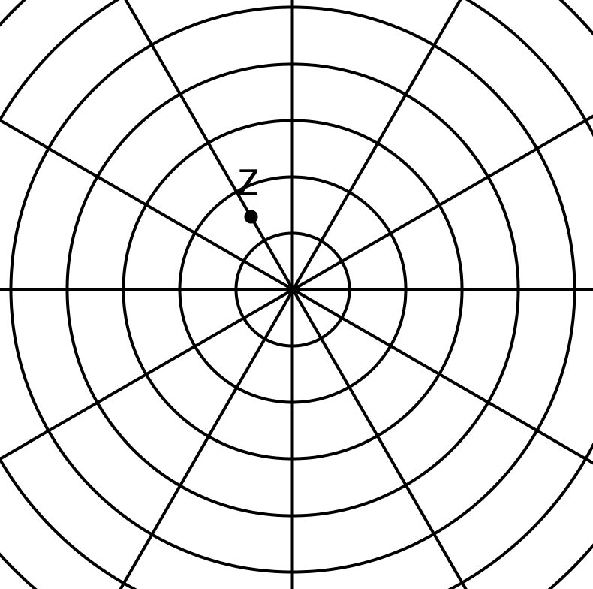 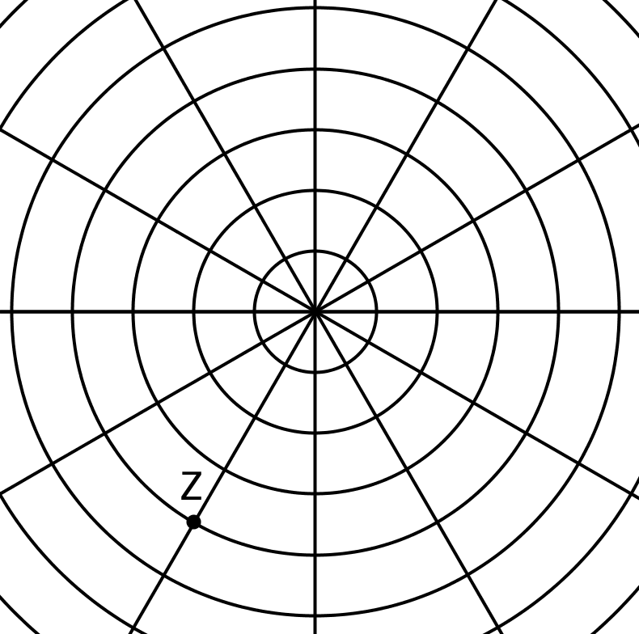

c) Find  *(two of them)* d) Find  *(three of them)* 