**PreCalc BC Polar ‘n’ Parametric Review Name:**

1. Sketch the following (check with calculator, *afterwards*).

a)  b) 

c)  d)  e)* 

\**think dbl angle formula*

2. Write equations (*in polar form)*:

a) *intcpts are integers* b) *x-intcpts are at 1, 2, 4, 8*

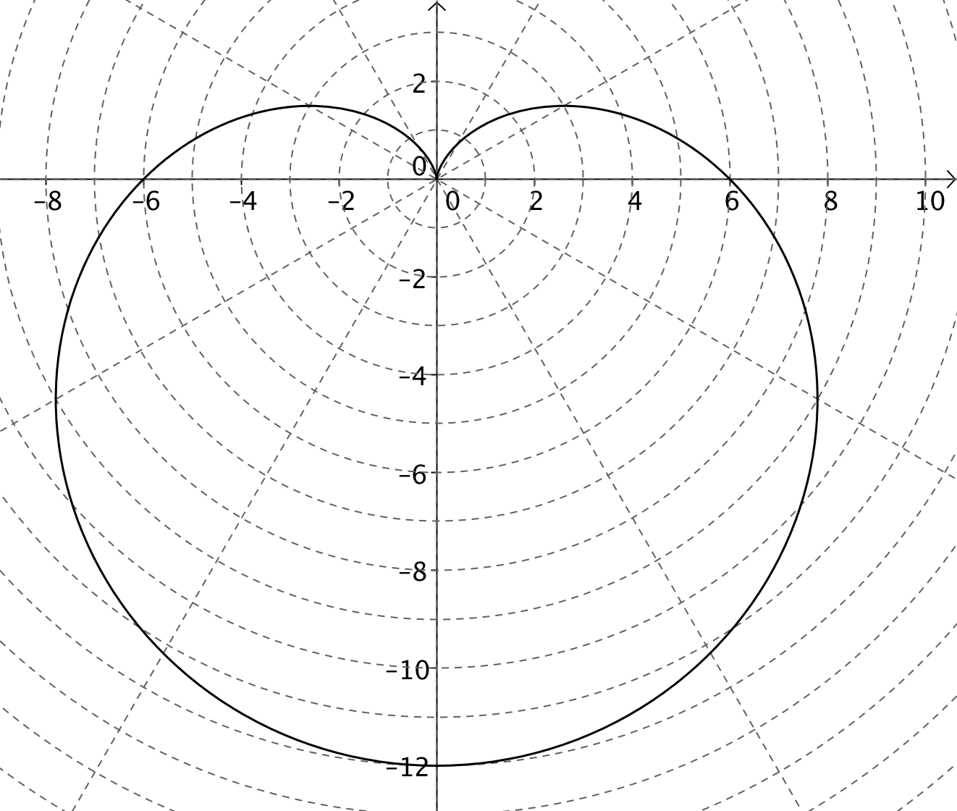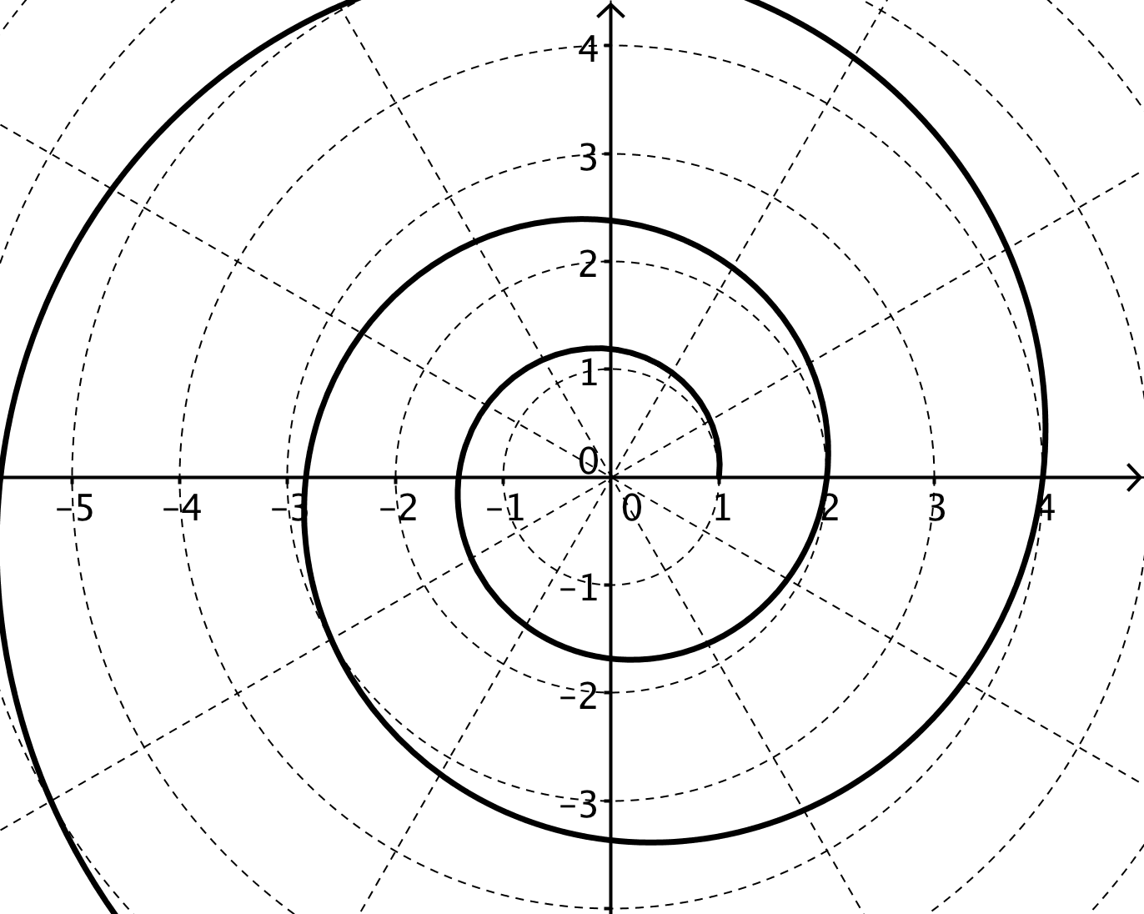

c) In polar form: y = 3 d) In polar form: y = 1/x

e) An archimedian spiral passing through [1, π/3].

3. Find the perimeter of a triangle whose coordinates are 

4. The graph of  is shown at right.

Sketch and label:

a) 

b) 

c) , *assuming *

5. Eliminate the parameter and sketch the graphs below:

a)  b)6. A receiver on a football team, with a head start of 20 yards, runs downfield at a speed of 9 yd/sec. The quarterback throws a pass at an angle of 28° and a velocity of 23 yd/sec. Assume both players are 2 yards tall, and the term for displacement due to gravity is: - 5.3 *t* 2 .

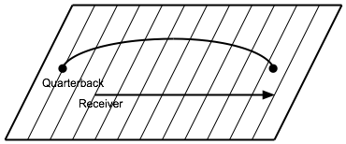

a) Set up a system of parametric equations:

receiver football

x(t) = ____________ x(t) = ____________

y(t) = ____________ y(t) = ____________

b) Find the distance between the ball and the receiver after 1.9 seconds*.*

*SHOW WORK*

7. A pebble becomes lodged in the tread of a 32” diameter tire rotating (along a road) at 3 revolutions per second. Write a system of parametric equations for the position of the pebble.

